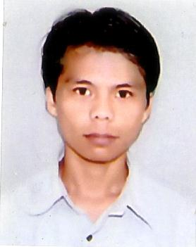

**Heikham Ashokumar Singh**

[rockyrock0109@gmail.com](mailto:rockyrock0109@gmail.com)

+918939439414

**Objective**

To succeed in an environment of growth and excellence and earn a job which provides me satisfaction and self development and help me to achieve organization goal.

**KEY LEADERSHIP QUALITIES**

* Team Building/Leadership.
* Staff Training.
* Business Planning.
* Operations Management.
* Marketing Program Development.
* New Business Development.
* Marketing Strategy.
* Budgeting.

**Work Experience**

* + Worked in Motorola Pvt. India Ltd. for 6 Month as a **Motorola** promoter in 2007.
  + Worked in **The Mobile store Retail ltd.** (Essar group of company) as a duty manager from 5th Feb 2008 to 3rd march 2010.
  + Worked at **Planet M** retails ltd. as a floor supervisor from 4th may 2010 to June 2011

**Educational Background**

* Passed MBA **in Marketing** at **Veltech Dr. RR & SR Technical University** in 2014**.**
* Passed BA with 2nd class from **D.M College** from Manipur University in 2007.
* Passed 12th with 2nd class Standard from **Board of Secondary Education Manipur** in2002.
* One Month course in Voice and Accent from NIIT Kolkata.
* 3 month course in MS Office, Typing and DOS.

**Industrial Implant Training and Project**

* A study on Sales and Distribution channel in ready solar Pvt Ltd. Chennai
* A study on Sales and Promotion in Big Bazaar, Perambur, Chennai

**Personal Details**

Father Name: H. Ranjit Singh

Mother Name: H. Sanamacha Devi

Present Address: No. 3

New Vallanur road near Veltech Technical University

Avadi, Chennai-600062.

Permanent Address: Luwangsangbam Mamang Leikai

P.O Mantripukhri, Imphal-East

Manipur-795002.

Date of Birth: 01-03-1985.

Contact No: +91-8939439414

**HOBBIES**

* Listening Music
* Playing Games (computer)

**PERSONAL REFERENCES**

**Veltech Dr. RR & SR Technical University.**

Date:

Place